**Review Worksheet ANSWERS – Specific Defences/Immunity**

1: What is meant by the term “Specific Defences” in immunity?

(3 marks)

*Specific Defences refers to the body’s response to specific pathogens (0.5) that enter the body. The immune system tailors a response to each pathogen (0.5), so that infection can be overcome (0.5) and so that in subsequent encounters (0.5) with the same pathogen (0.5), it is removed before symptoms develop (0.5).*

2: What two major types of white blood cell are involved in Specific Immunity?

(2 marks)

*Phagocytes (eg Macrophages) (1)*

*Lymphocytes (1)*

3: What is an antigen?

(1 mark)

*An antigen is any substance capable of triggering an immune response. (1)*

4: Which part of a pathogen can potentially be antigenic and provoke specific immunity?

(3 marks)

*The whole pathogen*

*Part of the protein coat*

*A toxin produced by the pathogen*

5: What things, other than pathogens, can be antigenic and provoke and immune response?

(3 marks)

*Foreign tissue eg: transplanted tissue (1)*

*Allergens (1) where the body responds inappropriately to harmless foreign particles (1)*

6: What types of cells are Antigen Presenting Cells (APC)?

(2 marks)

*They are phagocytes (1) eg: macrophages (0.5) and some lymphocytes (0.5)*

7: What is the function of APC in specific immunity?

(4 marks)

*APC encounter the pathogen (0.5) in extracellular fluid (including blood and lymph) (0.5) or in lymph nodes (0.5). They engulf the pathogen via phagocytosis (0.5) and destroy it (0.5). The APC then presents the antigenic part of the pathogen (0.5) on the APC surface (0.5), so it can be recognised by lymphocytes. (0.5)*

8: Where are lymphocytes produced and where can they be found?

(2 marks)

*Lymphocytes are produced in the bone marrow (0.5) and can be found in blood circulation (0.5), in tissue spaces (0.5) and in lymph nodes (0.5)*

9: B-lymphocytes (B-cells) and T-lymphocytes (T-cells) are both involved in specific immunity. Use the table to compare their production, maturation, location and function.

(4 marks)

|  |  |  |
| --- | --- | --- |
|  | **B-cells** | **T-cells** |
| **Site of Production** | *Bone Marrow (0.5)* | *Bone marrow (0.5)* |
| **Site of Maturation** | *Bone Marrow (0.5)* | *Thymus (0.5)* |
| **Location in Body after maturation** | *Lymphoid tissues and blood (0.5)* | *Lymphoid Tissues and Blood (0.5)* |
| **Function** | *Antibody-Mediated (Humoral) immunity (0.5)* | *Cell-Mediated Immunity*  *(0.5)* |

10: What type of specific immunity deals with pathogens:

(2 marks)

In body fluids? *Antibody-mediated Immunity (1)*

In cells? *Cell-mediated Immunity (1)*

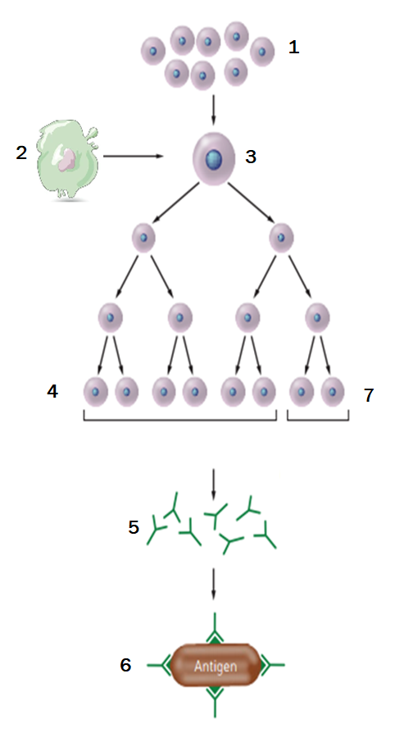11: Name the type of immunity that is occurring in the diagram below and describe what is happening at each step.   
(10 marks of 11.5 marks)

*The flow diagram shows the process of Antibody-Mediated*

*(Humoral) Immunity (1)*

*1: B-lymphocytes in lymphoid tissue (1)*

*2: Antigen Presenting Cell (APC) which has engulfed and*

*destroyed a pathogen (0.5), presents the antigenic site for*

*that pathogen on its surface (0.5).*

*3: The APC presents the antigen (0.5) to a B-cell with a*

*matching receptor (0.5).The B-cell becomes sensitised,*

*enlarges and divides (0.5), producing many more sensitised*

*B-cells. (0.5)*

*4: Most of these sensitised B-cells become plasma cells. (1)*

*5: The plasma cells produce antibody (0.5) specific for the*

*antigen (0.5) originally presented by the APC (0.5).*

*6: The antibody is released (0.5), and is then able to bind to*

*antigenic sites (0.5) on the same pathogens (0.5) as the one*

*originally presented by the APC (0.5), neutralising the*

*pathogens (0.5).*

*7: Sensitised Memory B-cells (0.5) remain in circulation, so that*

*the response proceeds more quickly (0.5) if the pathogen is*

*encountered again. (0.5)*

12: What are antibodies, when are they produced, and what do they do?

(6 marks)

*Antibodies are proteins (0.5) that are produced by B-lymphocyte (0.5) plasma cells (0.5), with receptors (0.5) for a specific pathogen (0.5). They are produced by the process of antibody-mediated (humoral) immunity (1). They neutralise (0.5) the specific pathogen (0.5) that has triggered the process (0.5), by binding to the antigenic site (0.5) on the pathogen (0.5).*

13: Describe the four main ways that antibody can neutralise pathogens.

(4 marks)

*Binding to active sites (0.5) so that the pathogen or toxin can no longer cause damage (0.5)*

*Sticking pathogens together into clumps (0.5) (agglutination) (0.5)*

*Reacting with soluble antigens to make them insoluble (1)*

*Inhibiting reactions (0.5) in foreign cells or compounds, leading to cell breakdown (0.5)*

14: How are pathogens disposed of after being neutralised by antibody?

*Phagocytosis (1)*

15: Indicate the first and second exposures to the pathogen on the graph below:

(2 marks)

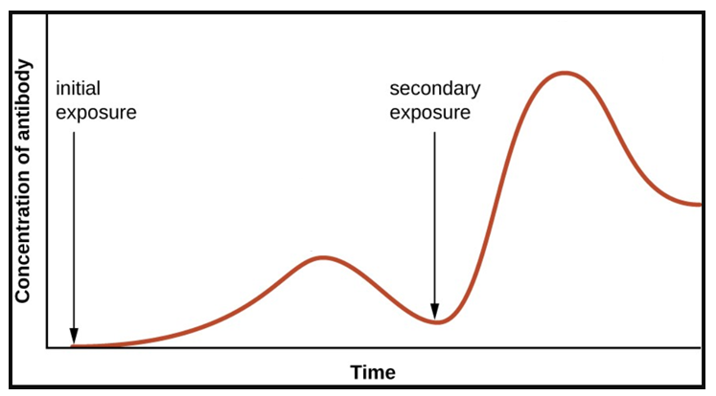

16: Referring to the graph above, explain why symptoms develop after the initial exposure to the pathogen but not after the secondary exposure.

(5 marks)

*When the pathogen initially invades, it takes time (0.5) for the process of phagocytosis, antigen presentation, B-cell cloning, and antibody production (0.5) to occur. In this time, symptoms will develop (0.5). During the process of antibody production, memory B-cells (1) are also created. The second time the pathogen invades (0.5), the memory B-cells detect the pathogen (0.5) much more quickly (0.5) and respond by rapidly cloning, and producing large amounts of antibody (0.5), eliminating the pathogen (0.5) before symptoms develop (0.5).*

17: What types of disease causing agents does cell-mediated immunity respond to?

(3 marks)

*Pathogens that have entered cells (1) eg: virus that is replicating within cells (0.5), some types of bacteria that live within cells (0.5), and also abnormal body cells such as cancer cells (0.5), or large foreign cells and organisms (0.5) eg tissue transplants, fungi, parasites. (0.5)*

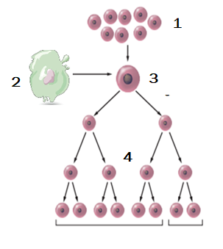

18: Describe in detail the processes shown in the diagram below.

(4 marks)

*1: T-cells (T-lymphocytes) in lymphoid tissue. ( 1 mark)*

*2: APC has engulfed pathogen (0.5) and presents antigen to one*

*type of T-cell (0.5).*

*3: T-cell is sensitised (0.5), enlarges and divides.(0.5)*

*4: Many clones of the T-cell are produced (0.5), sensitised for the*

*antigen that was presented (0.5).*

19: Four types of T-cell clones are produced. Name each and describe their functions.

(8 marks)

*Killer (Cytotoxic) T-cells (1): Cells that have been infected, or foreign cells have markers on their surface (0.5). Killer T-Cells attach to infected or foreign cells and destroy them (0.5).*

*Suppressor T-cells (1): Stop action of Killer T-Cells (0.5) once infected cells have been destroyed (0.5).*

*Helper T-cells (1): Secrete substances that sensitise more lymphocytes (0.5), attract macrophages and enhance macrophage activity. (0.5)*

*Memory T-cells (1): Remain sensitised to the specific pathogen (0.5), in circulation and tissues, so that future responses to the pathogen are much more rapid. (0.5)*

20:

(6 marks)

|  |  |  |
| --- | --- | --- |
| **Characteristic** | **Nervous System** | **Endocrine System** |
| Nature of Message | *Electrical impulses and neurotransmitters* | *hormones* |
| Transport of Message | *Along membrane of neurons* | *blood stream* |
| Cells affected | *Muscle and gland cells*  *Other neurons* | *Various (in some cases all) body cells and tissues* |
| Type of response | *Local, specific (mostly)* | *general, widespread (mostly)* |
| Speed of response | *Rapid – milliseconds* | *Slower – seconds to days* |
| Duration of Response | *Very brief. Stops quickly when stimulus stops* | *Longer lasting – hormones may take time make changes in target cells, and to clear.* |